**УО «Белорусский государственный университет информатики и радиоэлектроники»**

**Кафедра ПОИТ**

**Отчёт по лабораторной работе №2.1**

**По предмету**

**Основы алгоритмизации и программирования**

**Вариант 6**

**Выполнил:**

**Гладкий М.Г.**

**Проверила:**

**Данилова Г.В.**

**Группа 851001**

**Минск 2018**

**Задание:**

Многоугольник задан координатами своих вершин. Определить, является ли данный многоугольник выпуклым

**Код Delphi 10:**

**program** Project5;

{$APPTYPE CONSOLE}

**const**

Low = 3;

LowInt = -2147483648;

HighInt = 2147483647;

**var**

x,y : **array of** integer;

Num , Number , i , FirstVectorX , FirstVectorY : Integer;

SecondVectorX , SecondVectorY , Determinator : Integer;

FirstCounter , SecondCounter : Byte;

IsCorrect : Boolean;

**begin**

Writeln('This program checks, if the polygon is convex.');

Writeln('Enter the number of sides:');

IsCorrect := false;

**repeat**

**try**

Readln(Num);

**if** Num > 2 **then**

IsCorrect := true

**else**

Writeln('Its not polygon. Use numbers [',Low

,'..',HighInt,']');

**except**

Writeln('Use numbers [',Low ,'..',HighInt,']');

**end**;

**until** IsCorrect;

**if** Num = 3 **then**

Writeln('Triangle is always convex.')

**else**

**begin**

SetLength(x,Num + 1);

SetLength(y,Num + 1);

Number := Num - 1;

**for** i := 0 **to** Number **do**

**repeat**

IsCorrect := true;

**try**

Writeln('Enter the coordinates of point.');

Readln(x[i],y[i]);

**except**

Writeln('Use numbers [',LowInt ,'..',HighInt ,']');

IsCorrect := false;

**end**;

**until** IsCorrect;

x[Num] := x[0];

y[Num] := y[0];

FirstCounter := 0;

SecondCounter := 0;

**for** i := 1 **to** Number **do**

**begin**

FirstVectorX := x[i] - x[i - 1];

FirstVectorY := y[i] - y[i - 1];

SecondVectorX := x[i + 1] - x[i];

SecondVectorY := y[i + 1] - y[i];

Determinator := FirstVectorX * SecondVectorY - FirstVectorY *

SecondVectorX;

**if** Determinator > 0 **then**

inc(FirstCounter)

**else**

inc(SecondCounter);

**end**;

**if** ((FirstCounter > 0)**and**(SecondCounter = 0))**or**((FirstCounter =

0)**and**(SecondCounter > 0)) **then**

Writeln('Polygon is convex.')

**else**

Writeln('Polygon is not convex.');

**end**;

Readln;

**end**.

**Код С:**

#include <stdio.h>

#include <malloc.h>

int main()

{

const int HighInt = 2147483647, Low = 3;

int *x, *y, Num;

printf_s("This program checks, if the polygon is convex.\nEnter the number of sides:\n");

scanf_s("%d", &Num);

while (Num < 3)

{

printf_s("Its not polygon. Use numbers [%d..%d]\n", Low, HighInt);

scanf_s("%d", &Num);

}

if (Num == 3)

printf_s("Triangle is always convex.\n");

else

{

x = (int*)malloc(sizeof(int)*(Num + 1));

y = (int*)malloc(sizeof(int)*(Num + 1));

for (int i = 0; i < Num; i++)

{

printf_s("Enter the coordinates of point.\n");

scanf_s("%d %d", &x[i], &y[i]);

}

x[Num] = x[0];

y[Num] = y[0];

int FirstCounter = 0, SecondCounter = 0;

for (int i = 1; i < Num; i++)

{

int FirstVectorX = x[i] - x[i - 1], FirstVectorY = y[i] - y[i - 1];

int SecondVectorX = x[i + 1] - x[i], SecondVectorY = y[i + 1] - y[i];

int Determinator = FirstVectorX * SecondVectorY - FirstVectorY *

SecondVectorX;

if (Determinator > 0)

FirstCounter++;

else

SecondCounter++;

}

if (((FirstCounter > 0) && (SecondCounter == 0)) || ((FirstCounter == 0) &&

(SecondCounter > 0)))

printf_s("Polygon is convex.");

else

printf_s("Polygon is not convex.");

}

return 0;

}

**Скриншоты:**

**Delphi:**

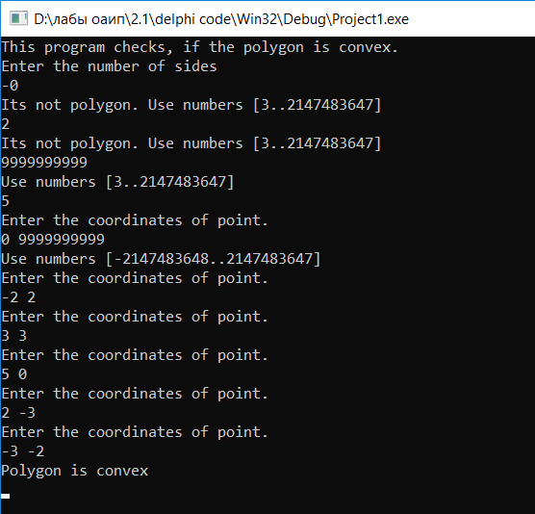

**С:**

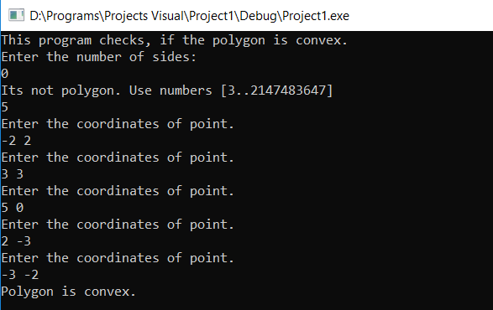

**Блок-схема:**

